Analyzing Air Travel in a Network Through the Lens of Sociology
Michael Mckenna

Introduction

The air transportation network of the United States is a culmination of decades of population change and infrastructure advancement. With routes radiating from the six largest domestic airports, this comprehensive network seamlessly connects every state and major metropolitan area, reflecting the nation's intricate socio-geographical landscape. This study embarks on an exploration of the complex interplay between air traffic, geography, and cultural influences by employing a Kamada-Kawai graph and agent-based model. The key question asked in this project is what patterns emerge from simulating air traffic routes as a force-directed graph and how can we interpret the data in terms of geography and culture?

Literature Review

There have been many related studies on both the dynamics of air transportation as a complex system, as well as the flow of agents in pedestrian traffic simulations and the tracking of flight as multiple nodes in a network. The most influential study to my project was “The worldwide air transportation network: Anomalous centrality, community structure, and cities' global roles” by Guimera, Mossa, Turtschi, and Amaral. This paper identified global air routes as a scale-free small-world network that could shed light on the economic ties between different localities as well as wider global industries. Their ability to extract information on a city’s global presence according to its air transport connections is a novel method of both data visualization and analyzing political economics. The lessons I learned from this study amounted to what type of inferences could be drawn from the data provided, as well as how I should visually assemble the data I’ve gathered. A study that provided significant background detail for my knowledge on the dynamics of air travel, as well as the applicability of complex systems thinking in reaction to aviation problems is “Identification of Key Nodes in Aircraft State Network Based on Complex Network Theory”. This paper establishes a method for identifying and assessing conflicts in commercial aviation landing and take off. The terminology and metrics used were very insightful as well as the corresponding visualizations in the study. Finally, the study titled “Large-scale agent-based simulation model of pedestrian traffic flows” was an enlightening read into the importance of human behavior in simulations of traffic. The presence of both logical and non-logical behaviors in simulating traffic is important to capturing realism in any model involving human inputs. That, as well as the implicit laws on human behavior used to guide the agent-based model informed my parameters and perspective of my project.

Technical Explanation of Model

The model consists of two essential layers and utilizes global variables for G, coordinates mapping, and edge lengths. The first layer is a Kamada-Kawai graph of the 6 largest US airports and how they connect to over 100 different airports in all 50 states. This is made by a function which uses a csv file named “CMPLXSYS 270 Final Project data.csv” with a spreadsheet of all airport connections between the six hubs and the distance in miles between airport pairs. The code extracts information about the airport codes and creates a list of edges (edges) and a dictionary of edge lengths. Then opening a csv file named “node_coordinates.csv” the code extracts the latitude and longitude of airports and creates a dictionary to map the nodes to their respective coordinates in the graph. The Kamada-Kawai graph uses the coordinates of the airports for positioning and edge distances are set by the dictionary of edge lengths. The graph accurately portrays relative distance between most cities and provides an insight to population trends and transportation efficiency.

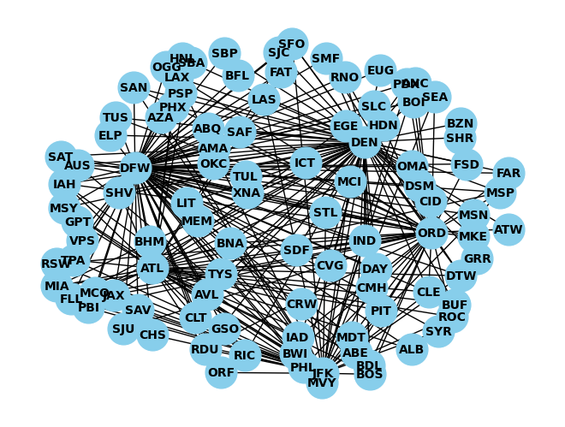
The second layer to the model is an agent based model (ABM) operating on an invisible network mirroring the Kamada-Kawai graph. The ABM is created by three functions. The first function creates the agents. The list of existing nodes in the first graph are randomized and halved to create the agents. Then those agents are positioned in a nested Kamada-Kawai layout on top of the existing graph. The next function moves the agents. By iterating through the variable agents, the code retrieves the starting position of an agent through the coordinates mapping attribute. Then it gets a list of neighboring nodes of the agent from the underlying graph. A neighboring node is randomly selected and the coordinates of the node are stored as the ending position of the moving agent. The shortest path is calculated between the destinations and the agent’s current node and then updates the agent’s position along the path to reach the destination node. The final function is the visualization of agent movement. It takes three parameters (the underlying graph, agent positions, and a list of agents) and essentially calls the previous functions in succession to animate the ABM.

Experiment Methodology

The experiment aims to analyze the dynamics of a two-layered model consisting of a Kamada-Kawai graph and an agent-based model (ABM) representing the US domestic air network. The study investigates the movement patterns of agents on the network as well as analyze metrics of the nodes representing airport locations within the network. The aim of this is to gain insights into population trends and transportation efficiency. Using a visualization function I can observe the movement of agents around the network and after running for 15 timesteps clear patterns were observed in the movement of agents in the graph. These patterns were compared to the underlying graph as well as topographical and political maps of the US to contextualize the results.

The Kamada-Kawai graph was used for finding the degree, closeness, and betweenness centralities of various airport locations. These metrics create a basis for comparison of hubs across the US. Degree centrality provides a simple view of the most well-connected airport. Closeness centrality is a strong indicator of interconnection, the ability for a flight to connect through a certain hub. Betweenness centrality reflects the density of airports located in proximity to a given hub airport. Because the network is an accurate representation of the air transportation network, the metrics calculated from the model, as well as the patterns that result from it are reinforced by legacy data taken on the flow of passengers through the airports the study focuses on.

Results

The number of routes each hub node has is incongruous with its status in the hierarchy of most used domestic passenger airports. This is a result of differences in the number of passengers on each route, as well as the existence of secondary airports within a single metropolitan area. However, the centrality metrics used in analyzing the model offers perspective on how the largest airports in the nation stack up against one another. Dallas is by far the best connected airport with the highest scores in all centrality metrics used. This is due to the fact that it is well located, being in a large and growing state while also being equidistant to both the east and west coasts. Denver and Los Angeles are similarly well-connected, yet with less routes than Dallas. Chicago’s centrality is a reflection of its position in the middle of the country. It isn’t as high as airports with more connections like Dallas or Los Angeles, however it finds itself as the connector between many east and west coast destinations. New York and Atlanta score similarly in centrality metrics, however their existence as international hubs is not accounted for.

Patterns develop in the model where agents travel from certain regions to particular hubs and vice versa. This behavior has clear sociological explanations when the patterns of the graph are seen with topographical and political perspectives. For instance, The majority of travel in Florida,Tennessee and the Appalachian region of North Carolina is to Atlanta. The majority of travel within the Northeast Corridor as well as significant travel in Florida is to New York. Identified by its low betweenness centrality, Chicago is a prime midwestern destination. Denver is the most trafficked destination of flights from the surrounding Rockies, as well as California. The majority of travel within the Southwest, as well as significant traffic from California and the Appalachian region is Dallas. Similarly, Los Angeles is another major hub for flights in the Southwest, California, and the Rockies.

Cities | Degree | Closeness | Betweenness
New York, NY | 0.42 | 0.6329 | 0.0867
Atlanta, GA | 0.39 | 0.6211 | 0.0812
Chicago, IL | 0.47 | 0.6536 | 0.0722
Dallas, TX | 0.84 | 0.8621 | 0.38
Denver, CO | 0.72 | 0.78125 | 0.2238
Los Angeles, CA | 0.72 | 0.78125 | 0.1901

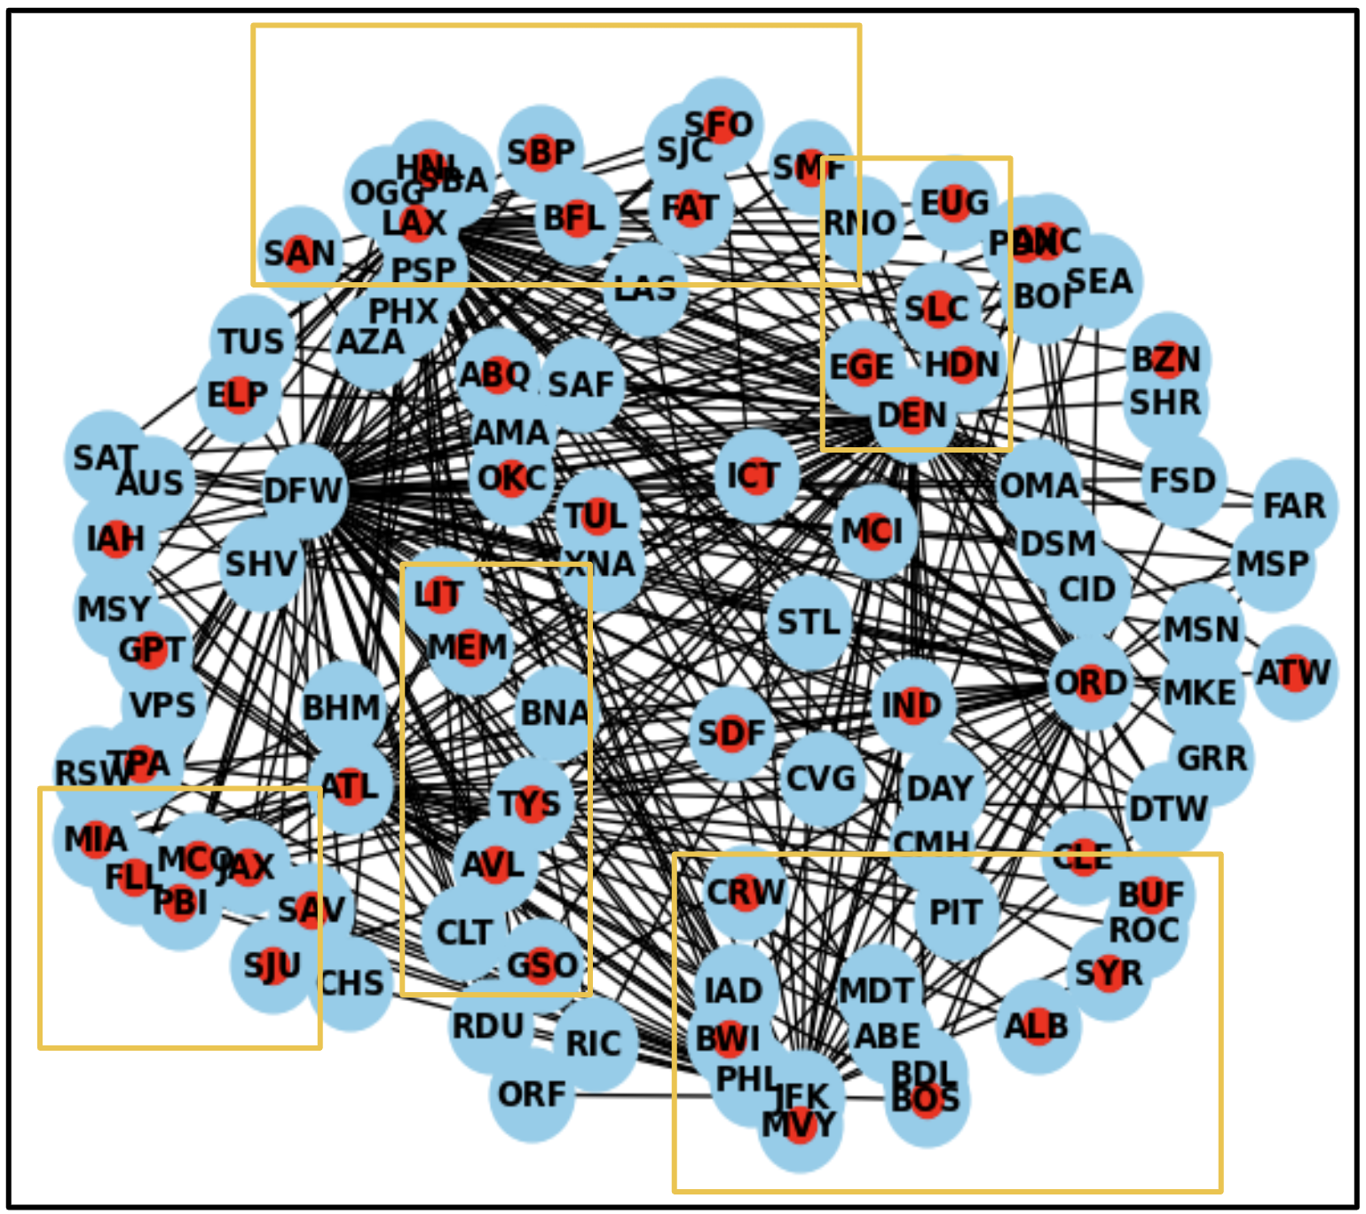

Limitations

The capabilities of my model are functionally limited to a subset of pre-existing data because of the practicality of collecting and visualizing data. The model represents a fixed number of hubs and airports which does accurately reflect the vast majority of air travel, however it doesn’t accurately represent all of domestic air travel. This scope means that there are certain fringe examples not accounted for in both simulated outcomes and conclusions drawn from the data. An improved model would not only increase the number of hubs and nodes but also change the shape of the graph as a result of more nodes and edges. The accuracy of the results may not be widely affected by the exclusion of a number of small Alaskan airports for example, however, there are further conclusions and observations that can be drawn from more extensive data being used.

Another limitation of the model is the realism in how the agents move. The agents don’t accurately portray a scaled down movement of actual airplanes because similarly to the distance issue, agents traveling to other nodes as an actual reflection of time and space would require altering the distance data to fit a non-spherical graph and would be very time consuming to iterate every scaled down mile traveled by the agent to its destination. The visualization of agent movement can be improved and if I were to revisit this project there would be a significant overhaul of the appearance and movement of agents simply for aesthetic purposes. Understanding the movements of agents could be made clearer with more fluid display but overall I believe that the primary purpose of changing this function would be aesthetics.

Most significant is the inability to maintain a consistent spatial scale within the model. Between agent movement and node distance there are aspects that don’t exactly conform with real-world scale. Because of the earth’s spherical shape, no 2-dimensional graph can accurately depict the true distance between two points that accurately preserves both the spatial separation and still provides the shortest path length. There is also the trouble of having outlier nodes that exist outside the continental US like Alaska and Hawaii being fit into the graph. In this sense a force-directed graph is quite limited in how it represents real world maps because the edges between nodes are created with a multitude of factors that define their distance. To counter that issue for the majority of nodes, preserving the distance by creating a separate dictionary of coordinates for each node works well. Adding more data to the model could improve the optics of the graph.

Implications/Conclusions

There are clear implications one can draw about the geographic limitations of surface level infrastructure from the results. In the case of Atlanta, the connections to many Appalachian and Piedmont cities despite being in such close proximity makes sense. The Appalachian mountains provide a significant physical barrier to overland travel from many destinations. Although many cities may be located within 100 or 200 miles of Atlanta, the roads connecting them are much longer and prone to natural weather conditions because of the terrain. The settlement of cities within this region is also a characteristic of the strong ties to Atlanta. Urban areas are sparsely situated within multiple valleys. Travel between these cities involves crossing mountain ridges and the largest major city is Atlanta. With economic opportunity, higher education, and international travel being widely available in Atlanta it makes sense that this region is closely linked to the largest hub in the Southeast. Similarly, the Rockies are home to many mid-sized cities separated by mountain ridges with poor surface infrastructure. The most common travel destination is the largest city Denver, because of its proximity to these communities. Interestingly, there are flights from ski destinations like Vail in Colorado to Los Angeles which are entirely supported by tourism. Some services to Denver are actually subsidized by the federal government because an air link with Denver is seen as an essential service under the Essential Air Service program.

The cultural implications of travel patterns are an interesting reflection of demographics and politics for the case of Los Angeles. Its distinctive cultural identity, notably marked by a sizable Hispanic population, creates a sense of unity with other Southwestern cities. The city's historical legacy as the frontier of both the Spanish and Mexican empires further reinforces these cultural ties. Beyond the role of Los Angeles as a hub for travel among a primarily Mexican-American populated area of the US, it is also the largest city in the largest state, California. Economically, Los Angeles serves as a pivotal commerce hub. With its largest international airport, LAX, acting as a gateway to the Pacific, the city plays a vital role in facilitating global trade and travel. Because of these factors, there is strong connectivity between Los Angeles and many locations in Northern and Central California.

Evolutions to Research

There is the potential for an expansion of the model to include all domestic airports and real time factors to affect the parameters. This benefits the realism of the model at the expense of both speed and simplicity. If I were to include more data points the simulation would become extremely crowded and nearly unnavigable to the average person. A moderate expansion of the number of hubs would provide deeper insight into the dynamics at play while also strengthening the results of the study. Expanding upon the Wang Zekun study and examining airports by centrality, as well as tendency for entropy could possibly predict the likelihood of congestion. Airport hubs that cater towards many distinct regions with no other alternative hub would be clear indicators of an overburdened and congested airport. This could be supported by a change in parameters and statistics involved. Collecting data on delays and coloring nodes based on changing frequency of delays would help visualize this situation.

Citations

Guimerà, R., Mossa, S., Turtschi, A., & Amaral, L. A. N. (2005). The worldwide air transportation network: Anomalous centrality, community structure, and cities’ global roles. Proceedings of the National Academy of Sciences, 102(22), 7794–7799. https://doi.org/10.1073/pnas.0407994102

Rocha, L. E. C. (2017). Dynamics of air transport networks: A review from a complex systems perspective. Chinese Journal of Aeronautics, 30(2), 469–478. https://doi.org/10.1016/j.cja.2016.12.029

Zekun, W., Xiangxi, W., & Minggong, W. (2019). Identification of Key Nodes in Aircraft State Network Based on Complex Network Theory. IEEE Access, 7, 60957–60967. https://doi.org/10.1109/ACCESS.2019.2915508

Nguyen, Q., Hong, S.-H., & Eades, P. (2011). TGI-EB: A New Framework for Edge Bundling Integrating Topology, Geometry and Importance. 7034, 123–135. https://doi.org/10.1007/978-3-642-25878-7_13

Kaziyeva, D., Stutz, P., Wallentin, G., & Loidl, M. (2023). Large-scale agent-based simulation model of pedestrian traffic flows. Computers, Environment and Urban Systems, 105, 102021. https://doi.org/10.1016/j.compenvurbsys.2023.102021

